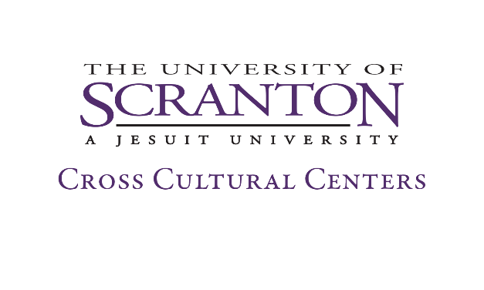

Student Staff Application

Name: _____________________________ Date:_____________________
Email Address: _______________________ Royal ID:__________________
Major/Minor:_________________________ Phone: ___________________ Graduation Year: _____________________
WORK STUDY: Did you receive federal work study allocation from Financial Aid? Yes ___ No___
INTERN: What program/department is this internship for? _______________________________

When are you available to work (the JKWC is generally open 8:30am to 4:30pm Monday through Friday, with extended hours on some evenings)?
 | Monday | Tuesday | Wednesday | Thursday | Friday
Times Available:
Total Hours:
*Please note: all staff are required to a 1-hour Jane Kopas Women’s Center staff meeting every week, and a 1 hour full Cross Cultural Centers Staff meeting once per month.
Do you have previous experience with any of the following skills? (Check all that apply)
__Publicity __Event Planning __ Social Media __Peer Education
__Office Support __Microsoft Office __Assessment __ Website Development

What areas within feminism or gender issues interest you?
__Environmental Justice __Media Representation
__Women’s Health __Pay Gap/Wage Equity/Glass Ceiling
__Body Image Integrity __Masculinity
__Patriarchal religions __Global Gender Issues
__Gender Roles __Women’s Leadership
__Hookup culture __ LGBTQIA+ issues
__Blogging/Social Media __Double Standards
__Motherhood/Parenting Other:_________________

Why are you interested in interning in the Jane Kopas Women’s Center?
______________________________________________________________________________________________________________________________________________________________________________________________________________________________________________________________.

What experiences do you have in the areas of diversity, social justice and gender equity issues?
______________________________________________________________________________________________________________________________________________________________________________________________________________________________________________________________.

What knowledge and skill sets would you like to gain from your experience at the Women’s Center?
______________________________________________________________________________________________________________________________________________________________________________________________________________________________________________________________.

Thank you for your interest in the Jane Kopas Women’s Center. Please email (jkwc@scranton.edu) or drop off your application and resume at the Jane Kopas Women’s Center, The DeNaples Center 205F).

Please note: As per the University Non-Discrimination Statement, "The University of Scranton is committed to providing a safe and nondiscriminatory employment and educational environment. The University does not discriminate on the basis of race, color, national origin, sex, disability, religion, age, veteran status, gender identity or expression, sexual orientation, or other status protected by law. Sexual harassment, including sexual violence, is a form of sex discrimination prohibited by Title IX of the Education Amendments of 1972. The University does not discriminate on the basis of sex in its educational, extracurricular, athletic, or other programs or in the context of employment." This statement applies to the selection of Cross Cultural Centers student staff.

