COMMITTEE ON THE STATUS OF WOMEN
Thursday December 9th, 2021
8:30 – 9:30 am
Individuals Present: Cara Krieg, Pauline Palko, Peter Bouraphael, Donald Bergmann, Billie Tadros, Sam Gurn, and Maria Marinucci.
Individuals Absent: Lucia Alaimo, Amy Atkinson, Elizabeth Garcia, and Jennifer Riccardi.
AGENDA
- Approval of Minutes:

  - Minutes for previous meeting were unanimously approved by the committee.

- Open Forum/Community Concerns:

  - N/A—no community members present for meeting.

- Committee Name Change:

  - The provost has approved the committee’s request for a name change “without hesitation.” Beginning in the spring semester of 2022, the committee will be known as the “Committee on Gender Equity.”
  - The Committee on Gender Equity will remain independent from CDI but will seek to collaborate with them whenever it is necessary.
  - Mission statement and bylaw changes needed to accommodate the name change:
    - Changes to the current CSW website are planned for intersession.
    - The following suggestions were made concerning changes to the current CSW mission statement and history:
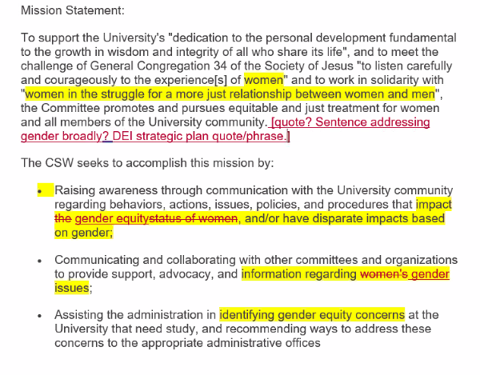

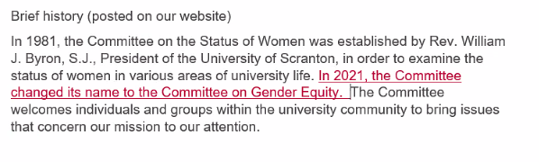

  - Discussion of education concerning the committee’s name change:
    - Cara will update the faculty senate that the name change has occurred during their meeting on December 10th, 2021. She will also speak with Adrianna Smith from student government.
    - Pauline will be responsible for updating the staff senate.
    - The committee unanimously agreed that an educational component should only be prepared if it is asked for by a concerned party.

- Website Photo:

  - Sam is going to be working on a stained-glass idea for a new website photo.
  - We would like to have this new image by February 2022.

- New Business:

  - N/A—No new business

