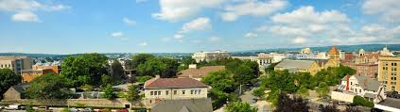  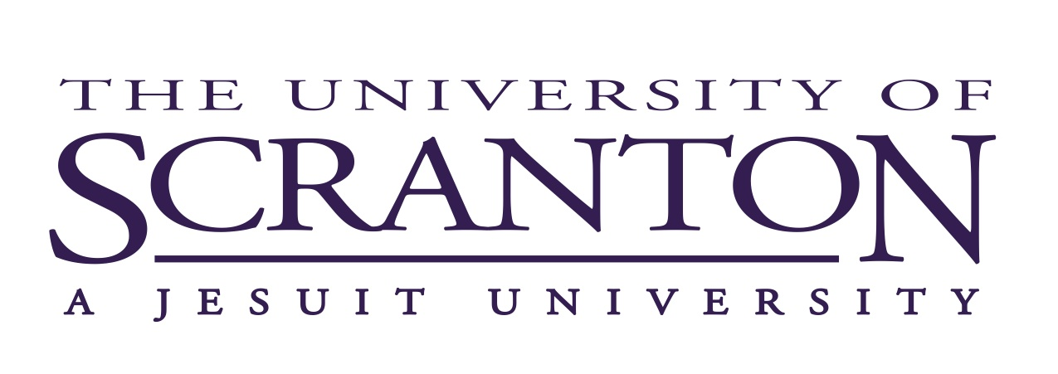  Community-based learning clinic  Teaching a Community-Based Learning Course or Thinking about Teaching One in the Future?  This workshop will give faculty the opportunity to share tips, techniques, and community connections for teaching community-based learning courses with other CBL faculty and members of the Community-Based Learning Board. No past experience of CBL is necessary! Best practices and lessons learned welcome!  RSVP by Oct. 25 to: Sharon Olechna, sharon.olechna@scranton.edu | Thursday, November 1  11:30-12:45  ────  Provost’s Conference Room  STT 5114  ────  Lunch will be provided!  ────  Bring your questions and examples of CBL courses  University of Scranton  Office of Community-Based Learning  Contact: Meghan Ashlin Rich, Faculty Coordinator of the Office of CBL: meghan.rich@scranton.edu

