Scranton Social Security Administration Office
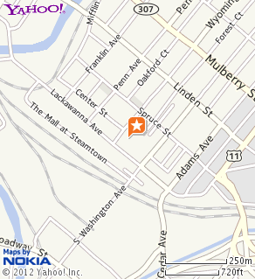
Office Address :
Oppenheim Bldg 1st Flr
409 Lackawanna Ave
Scranton, PA 18503

Hours: 9:00-3:30 pm

Directions :

Office is located in Oppenheim Building, across from the Steamtown Shopping Mall, in downtown Scranton.

Original documents you need for application for a Social Security Number ( SSN )
Immigration status
If you are an F-1 or M-1 student, you must show your I-20, Certificate of Eligibility for Nonimmigrant Student Status. If you are a J-1 or J-2 exchange visitor, you must show your DS-2019, Certificate of Eligibility for Exchange Visitor Status.
Work eligibility
In general, only noncitizens who have permission to work from DHS can apply for a Social Security number. For most foreign workers, we only need to see an I-94, Arrival/Departure Record, showing a class of admission permitting work. Some foreign workers must show their work permits from DHS (I-766).
Student: If you are an F-1 student and eligible to work on campus, you must provide a letter from your International Student and Scholar Services staff that:
- Identifies you;
- Confirms your current school status; and
- Identifies your employer and the type of work you are, or will be, doing. *
( *Note: If you do not have an employment offer, the International Student and Scholar Office will not be able to provide the letter to support your application for a SSN)

The Social Security Office will also need to see evidence of that employment, such as a recent pay slip or a letter from your employer. Your supervisor must sign and date the letter. The letter must describe:
- Your job;
- Your employment start date;
- The number of hours you are, or will be, working; and
- Your supervisor's name and telephone number.
If you are an F-1 student authorized to work in curricular practical training (CPT), you must provide Form I-20 with the employment page (page 3) completed and signed by the International Student and Scholar Services staff.
If you are a J-1 student, student intern or international visitor, you must provide a letter from your sponsor. The letter should be on sponsor letterhead with an original signature that authorizes your employment.
Age
Bring your passport to show evidence of your age.
Identity
Social Security will ask to see a current DHS document. Acceptable documents include:
- Form I-551 (includes machine-readable immigrant visa) with unexpired foreign passport;
- I-94 with unexpired foreign passport; or
- I-766 work permit from DHS. ( if applicable )

